University Džemal Bijedić Mostar

Faculty of information technologies

Weather forecast using Markov chain

Seminarski rad iz predmeta Modeliranje i simulacija

Mentor: Student:
prof. dr. Migdat Hodžić Zorka Kunovac

Mostar, juni 2022. godine

Contents
1. Introduction 1
2. Business understanding and methods 3
2.1. Markov chain 5
2.2. Chapman-Kolmogorov Equations 8
3. Results 10
4. Discussion and Future work 18
5. Conclusion 19
6. References 20

Table of Figures
Figure 1: Markov property: Given X(tk), X(tk+1) is independent of samples prior to tk [8]. 6
Figure 2: Transition probability matrix [8] 7
Figure 3: Chapman-Kolmogorov equation [10] 8
Figure 4: Derivation of equation [10] 8
Figure 5: Markov state diagram of weather changes 10
Figure 6: Markov state diagram of weather changes with Risk estimation included 14
Figure 7: Calculation of probability for first scenario 15
Figure 8: Multiplying row with transition matrix 15
Figure 9: Multiplying second row with transition matrix 15
Figure 10: Eigenvector equation [15] 16
Figure 11: Eigenvector equation applied to this task [15] 16
Figure 12: The process of reaching stationary state for Sunny, Cloudy and Rain states. 16
Figure 13: Calculation of probability for first scenario 17
Figure 14: Scenario with highest probability 17

List of Tables
Table 1: Weather in Mostar for period of 21 days 4
Table 2: Input parameters to estimate risk 5
Table 3: Transition probability matrix for weather 10
Table 4: Evaluation of the risk of time for human health 13
Table 5: Transition probability matrix for risk 14

Abstract

In recent years, the weather has changed dramatically. There are more and more sudden changes in the weather when in just one day the temperatures drop or rise by 20 degrees, and then people usually feel that familiar pressure. The symptoms and ailments people feel during weather changes are called meteoropathy, As the weather shifts from winter to spring, it is not uncommon to hear people both young and old complaining about aches and pains. The goal of this project is weather forecasting and determining the impact of weather and weather changes on human health using the Markov chain.

Keywords: weather, weather forecasting, health, Markov chain

Introduction

Can a sudden change in the weather affect human health? Changes in weather are challenges to the immune system and to the musculoskeletal system. Human bodies get used to a certain climate, and when those things change suddenly, the human body has to try to adapt. Unfortunately, sometimes our bodies have a difficult time adjusting, which can trigger an illness [1].
During this research, it was discovered that there are six main symptoms caused by weather changes [2].
- Changes in blood pressure
Blood pressure can vary for a number of reasons, including weather. Namely, when there are sudden changes in weather, there are changes in pressure, and this directly affects our body. Under the influence of high temperatures, blood vessels dilate, which can lead to a drop in blood pressure. At low temperatures, blood vessels constrict, which can increase blood pressure.
- Headache
People who are otherwise prone to headaches find it difficult to tolerate sudden and extreme changes in the weather. Migraine attacks are also common.
- Sleep problems
Time also affects sleep. In summer, due to high temperatures, people cannot fall asleep, while by entering the autumn scheme, people start sleeping longer. A study published in the Journal of Psychosomatic Research showed that respondents during October and autumn, respectively, slept up to three hours longer than at any other time of the year. Unfortunately, that does not mean they were more rested. Respondents did not feel better and more energetic, on the contrary, they were more tired than when they slept less [2].
- Increased number of heart attacks
When temperatures are lower, the blood flows more slowly through the veins, and this greatly affects the heart. It is known that during colder days the risk of heart attack increases. Unfortunately, extreme heat also makes the heart work harder and increases the risk of heart attack.
- Breathing problems
Extremely high or low temperatures negatively affect the respiratory system, so breathing problems are not uncommon.
- Weakened immune system
Sudden and extreme weather changes are a direct hit on the immune system. That is why it is often the case that people catch a cold due to the change of weather, regardless of the season [2].
The term meteoropathy refers to difficulties associated with weather changes (temperature, humidity, and atmospheric pressure). There is also a difference between meteorologically sensitive people and meteorologists. According to the generally accepted definition, meteorologically sensitive people are individuals who have health problems or worsening of chronic diseases associated with bad weather and weather changes, while in meteorologists the symptoms and difficulties are more pronounced. Symptoms of meteoropathy usually appear 24 to 48 hours before the change of weather, last a day or two and pass or recede when the organism adapts to new weather conditions [3].

Business understanding and methods

With sudden changes in temperature, atmospheric pressure or humidity, sensitive people most often complain of irritability or low and depressed mood, describe feelings of mental and physical weakness, fatigue, drowsiness, and desire to stay home. Body symptoms may include high blood pressure, headache, increased sensitivity to joint and muscle pain, difficulty breathing and a feeling of heaviness in the stomach, symptoms of the cardiovascular system, such as rapid heartbeat or chest pain. These symptoms last for one or two days [3,4]. They begin to decrease when the weather changes but reappear when the weather gets worse. When weather changes alternate in the correct order, the intensity of symptoms decreases as the body adapts [3].
Meteoropathy is a disease of the modern age and is related to the modern way of life. Prolonged stay indoors and in air-conditioned spaces reduces the ability of our body to adapt to changes in weather conditions. Research indicates that middle-aged and older people, especially women, but also children, are at increased risk. People who have mental and behavioral disorders, especially anxious and depressed people, are more susceptible to meteorology. Nowadays, this instability is influenced by the increase in the frequency of negative factors in life like stress in personal and work environment, difficulties in finding a job or economic difficulties in retirement, loss of human and family values, and last but not least, environmental pollution - so-called atmospheric and sound pollution [3].
Everyone has a different level of sensitivity to weather changes. People who engage in regular physical activity and those who spend a few hours a day outdoors usually do not notice changes in the weather or tolerate the symptoms of meteoropathy more easily. On the other hand, older people, people who have had surgery, people whose occupations include prolonged sitting at work and using a computer, may feel symptoms at every change of time [3,5].
The goal of this project is, as mentioned before, weather forecasting and to determine its impact on human health. The following methods were used to detect these problems within this project. For weather forecasting were used Markov chains. Firstly, it was necessary to collect historical data on actual weather events [6]. The weather forecast in Mostar was observed for a period of 21 days, specifically the period from May 20 to June 9. For each day, three states were observed: sunny, cloudy, rain. These conditions are also recorded in the excel table shown in Table 1, where 1 indicates that weather for that day was in that state and 0 if was not.
Table 1: Weather in Mostar for period of 21 days
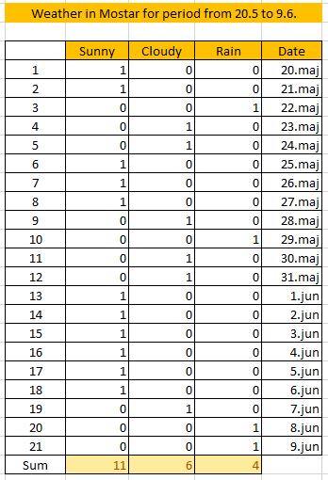
The following questions were sought to be answered [14]:
- If the system is in the Sunny state, what is the probability that it will stay in the Sunny state on the next observation?
- If the system is in the Sunny state, what is the probability that it will be in the Cloudy state on the next observation and what is the probability that it will be in the Rain state?
- If the system is in the Cloudy state, what is the probability that it will stay in the Cloudy state on the next observation?
- If the system is in the Cloudy state, what is the probability that it will be in the Sunny state on the next observation and what is the probability that it will be in the Rain state?
- If the system is in the Rain state, what is the probability that it will stay in the Rain state on the next observation?
- If the system is in the Rain state, what is the probability that it will be in the Cloudy state on the next observation and what is the probability that it will be in the Sunny state?
- What is the most likely time series for the observed health states or vice versa?
After estimating the probability of the weather forecast, the process of which will be explained in more detail in the chapter Results, additional data on minimum temperature, maximum temperature and air pressure were collected from the same location. As previously mentioned, human health is most affected by temperature changes but also atmospheric pressure, so with the help of these data as input parameters will determine the negative impact on health. Collected data for the mentioned period are shown in Table 2.
Table 2: Input parameters to estimate risk
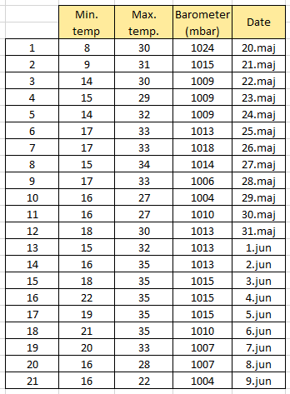

Markov chain

In mathematics, the Markov chain named after Andrei Andreyevich Markov represents a series of states of the system. At any time, the system may go into a new state or may remain in the same state. Changes in the state are called transitions. The future states of the process depend only upon the present state, not on the past states leading up to the present state. This property is called the Markov property. Any stochastic process that possesses the Markov property is called a Markov chain. More specifically, to satisfy the Markov property, given the present state X_{n} and the past states X_{n-1}, X_{n-2}, . . ., X₂, X₁, X₀, the conditional distribution of the future state X_{n+1} depends only on the present state X_{n}. Even more specifically, to satisfy the Markov property, the process must satisfy the following requirement [7]:
[7]
for all possible states x₀, x₁, . . ., x_{n-1}, i, j and all non-negative integers n. Thus, under the Markov property, the conditional distribution of the future state X_{n+1} depends only on the present state X_{n} and that all the states preceding the present state have no influence on the future state [7].
The conditional probabilities P [X_{n+1} = j | X_{n} = i] in (1) are called transition probabilities of the Markov chain.
Markov chains are often described by a direct graph where the edges are marked by a probability representing the transition from one state to another.
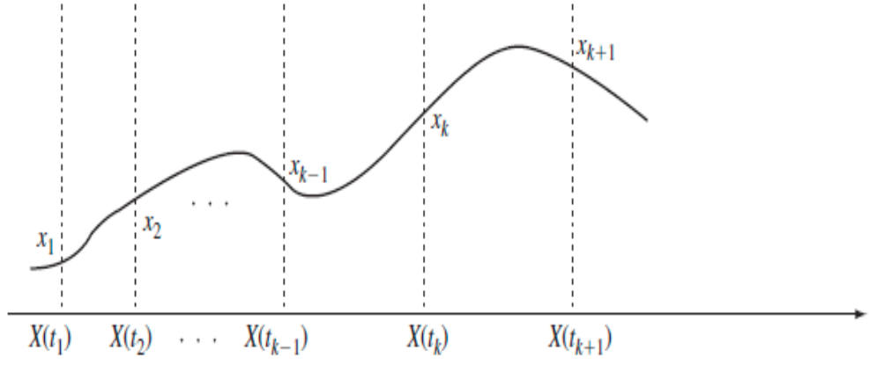
Figure 1: Markov property: Given X(tk), X(tk+1) is independent of samples prior to tk [8].
There are considered only the Markov chains in which the transition probabilities P[X_{n+1} = j | X_{n}=i] are independent of the current period n. Such Markov chains are called time-homogeneous Markov chains or stationary Markov chains. So, the additional assumption of time-homogeneity means that the probability of transitioning into state j from state i is identical regardless of where the process is in the time scale
With the transition probability P[X_{n+1} = j | X_{n} = i] independent of n, this probability can be denoted by the states i and j only:
The probability P_{ij} represents the probability that the process, starting in state i, will enter into state j in the next period. Since the process must transition into one of the states in the state space in the next time period, P_{ij}, with i fixed and j varying, must represent a probability distribution. Thus P_{i0} + P_{i1}+ … =1. Here we assume that the state space is the set of all non-negative integers [7].
The probabilities P_{ij} are called one-step transition probabilities since they give the probabilities of transitioning from one state to another state in one period of time. The one-step transition probabilities are usually expressed in a matrix or a transition diagram. The following shows what a transition probability matrix looks like [7].
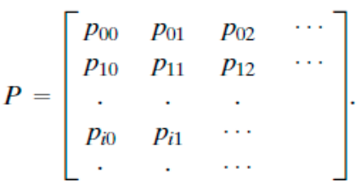
Figure 2: Transition probability matrix [8]
The indicated matrix is called the transition matrix and is usually denoted by P, and its elements, where the indices p_{ij}, are from the set of all states. The matrix P can also be written using a tree. Each row of P must add to one since
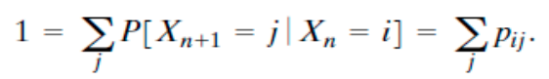
As mentioned before, if the Markov chain is finite state, then the matrix P will be an n x n nonnegative square with rows that add up to 1 [8].
So, matrix is called stochastic if
- All entries are greater than or equal to zero.
- The sum of the entries in any column is one.
All the properties of Markov chains are derived from the transition probability matrix. One of the tasks is to develop a way to calculate the transition probabilities. The elements of the transition probability matrix P are the one-step transition probabilities p_{ij}, which gives the probability of going from state i into state j. The next step is to calculate the n-step transition probabilities P^{n}_{ij}, which is the probability that the process will in state j in the nth period given the process is initially in state i. So, there comes Chapman-Kolmogorov equations, a systematic way of calculating transition probabilities using matrix multiplication.

Chapman-Kolmogorov Equations

Let Q_{n} be the n-step transition probability matrix. The goal now is to have a systematic way to compute the entries in the matrix Q_{n}. The computation is based on the Chapman-Kolmogorov equations. These equations are [10]:
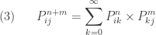
Figure 3: Chapman-Kolmogorov equation [10]
for n, m >= 0 and for all i, j. For a finite-state Markov chain, the summation in (3) does not go up to infinity and would have an upper limit. The number P ^{n+m} _{ij} is the probability that the chain will be in state j after taking n+m steps if it is currently in state i. The following gives the derivation of (3) [10].
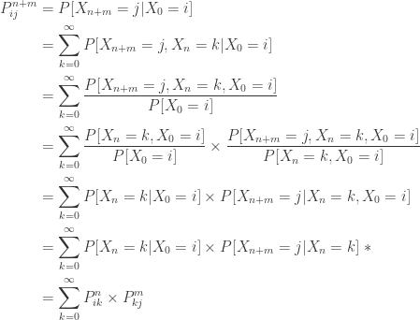
Figure 4: Derivation of equation [10]

The path from state i to state j in n+m steps can be broken down into two paths, one from state i to an intermediate state k in the first n transitions, and the other from state k to state j in the remaining m transitions. Summing over all intermediate states k yields the probability that the process will go from state i to state j in n+m transitions.
The entries in the matrix Q_{n} can be then computed by (3). There is an interesting a useful interpretation of (3). The following is another way to state the Chapman-Kolmogorov equations:
A typical element of the matrix Q_{n} is P^{n}_{ik} and a typical element of the matrix Q_{m} is P^{m}_{kj}. Note that P^{n}_{ik} with k varying is a row in Q_{n} (the row corresponding to the state i) and that P^{n}_{kj} with k varying is a column in Q_{m} (the column corresponding to the state j) [10].
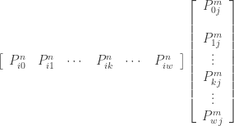 [10]
The product of the above row and column is the transition probability P ^{n+m} _{ij} .
Again, let P be the one-step transition probability matrix of a Markov chain and let Q_{n} be the n-step transition probability matrix, which can be computed by using the Chapman-Kolmogorov equations [10].
The n-step transition probability matrix Q_{n} is obtained by multiplying the one-step transition probability matrix P by itself n times, i.e., Q_{n} is the nth power of P [10].
This fact is important in terms of calculation of transition probabilities. Compute P^{n}, the nth power of P (in terms of matrix calculation). Then P^{n}_{ij} is simply an entry in P^{n} (in the row that corresponds to state i and in the column that corresponds to state j) [10].

Results

In the previous chapter, Table 1 was shown weather in Mostar for period of 21 days (about 3 weeks), specifically the period from May 20 to June 9 and then certain questions were asked about the states. In order to make an appropriate transition matrix, it was necessary to answer those questions. As the name suggests questions are related to transition between three previously mentioned states: Sunny, Cloudy and Rain. From table in Table 1 the following can be concluded:
- The system was in state Sunny in 11 cases. In 8 cases the system remained in the Sunny state.
- Out of 11 Sunny cases, in 2 cases, the system transitioned from Sunny to Cloudy and in only 1 case to Rain.
- The system was in state Cloudy in 6 cases. In 2 cases the system remained in Cloudy states.
- Out of 6 cases, in 2 cases the system transitioned from Cloudy to Sunny and in 2 cases to Rain.
- The system was in state Rain in 4 cases. In two cases the system transitioned from Rain to Cloudy and once system remained Rain.
According to this research, a transition matrix was made in the form shown in the Table 3.
Table 3: Transition probability matrix for weather
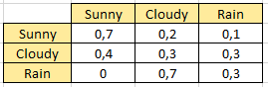
The Markov state diagram of weather changes in the Figure 5 graphically describes Transition probability matrix shown in Table 3.
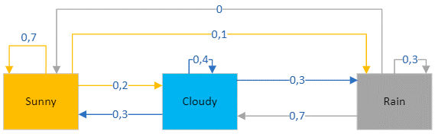
Figure 5: Markov state diagram of weather changes
But the task is not finished, in Table 2 are shown input parameters to estimate risk for people health. From collected data for mentioned period is necessary to determine which combination of input parameters represent risk for human health. But before that, it is necessary to explain what barometer is, how it works and what atmospheric pressure is and how it affects human health.
A barometer is a device that reads atmospheric pressure. It uses liquid mercury to predict the weather by tracking atmospheric pressure changes resulting from the movement of warm and cold weather systems [11]. Barometric Pressure, also known as “Atmospheric Pressure” or “Air Pressure,” is the weight of the earth’s atmosphere. This pressure varies depending on geographic location and can also change depending on the amount of hot or cold air— hot air being lighter and less dense than cold air [1].
The air that surrounds the Earth creates atmospheric pressure and this pressure is determined by the collective weight of air molecules. Higher air molecules have fewer molecules pressing down on them from above and experience lower pressure, while lower molecules have more force or pressure exerted on them by molecules piled on top of them and are more tightly packed together. At the mountains or fly high in an airplane, the air is thinner, and the pressure is lower. The air pressure at sea level at a temperature of 15°C is equal to one atmosphere (Atm) and this is the baseline reading for determining relative pressure. A rising barometer indicates increasing atmospheric pressure, and a falling barometer indicates decreasing atmospheric pressure [11].
Changes in air pressure are caused by differences in air temperature above the earth, and the temperature of an air mass is determined by its location. For example, air masses above oceans are typically cooler than air masses above continents. Air temperature differences create wind and cause pressure systems to develop. The wind moves pressure systems, and these systems tend to change as they pass over mountains, oceans, and other areas. Often, weather forecasters refer to high- or low-pressure areas moving toward particular regions in order to describe predicted conditions for those areas. As air rises in low-pressure systems, it cools and often condenses into clouds and precipitation, resulting in storms. In high-pressure systems, the air sinks toward the Earth and warms upward, leading to dry and fair weather [11].

Here are a few examples of how to interpret barometric readings [11]:
- When the air is dry, cool, and pleasant, the barometer reading rises.
- In general, a rising barometer means improving weather.
- In general, a falling barometer means worsening weather.
- When atmospheric pressure drops suddenly, this usually indicates that a storm is on its way.
- When atmospheric pressure remains steady, there will likely be no immediate change in the weather.
High Pressure
A barometric reading over 30.20 inHg is generally considered high, and high pressure is associated with clear skies and calm weather [11].
If the reading is over 30.20 inHg (102268.9 Pa or 1022.689 mb):
- Rising or steady pressure means continued fair weather.
- Slowly falling pressure means fair weather.
- Rapidly falling pressure means cloudy and warmer conditions.
Normal Pressure
A barometric reading in the range of 29.80 and 30.20 inHg can be considered normal, and normal pressure is associated with steady weather [11].
If the reading falls between 29.80 and 30.20 inHg (100914.4–102268.9 Pa or 1022.689–1009.144 mb):
- Rising or steady pressure means present conditions will continue.
- Slowly falling pressure means little change in the weather.
- Rapidly falling pressure means that rain is likely, or snow if it is cold enough.
Low Pressure
A barometric reading below 29.80 inHg is generally considered low, and low pressure is associated with warm air and rainstorms [11].
If the reading is under 29.80 inHg (100914.4 Pa or 1009.144 mb):
- Rising or steady pressure indicates clearing and cooler weather.
- Slowly falling pressure indicates rain.
- Rapidly falling pressure indicates a storm is coming.
Weather researchers (meteorologists) use a metric unit for pressure called a millibar. They define the average pressure of a given point at sea level and 15°C as one atmosphere or 1013.25 millibars [11]. This is important because the data for the Barometer input parameter in this project is expressed in millibars (mbar).
Some research has shown that the patients developed a migraine when the atmospheric pressure was within 1003–1007 hPa in the approach of low atmospheric pressure and that the patients developed a migraine when the atmospheric pressure decreased by 6–10 hPa, slightly less than the standard atmospheric pressure. That study included 34 patients with migraine who received medical care at hospital. The study population consisted of 31 females and three males, with a mean (±SD) age of 32 (±6.7) years [12].
Table 4: Evaluation of the risk of time for human health
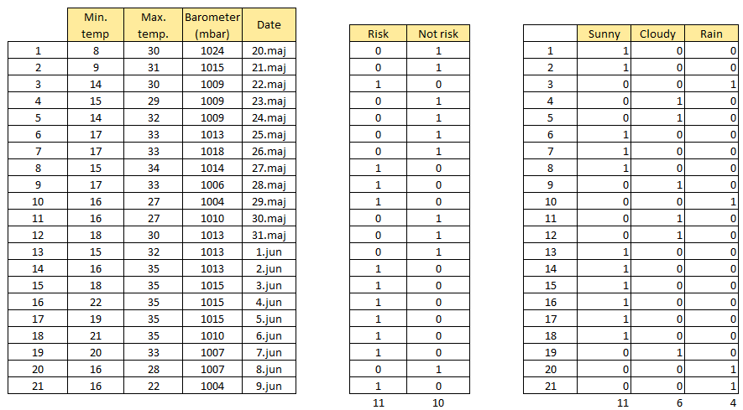
For easier review and comparison, three tables are shown here. The left table shows the input data. Middle table is risk estimation for given data. From the previous studies, it can be concluded that low atmospheric pressure causes health problems, so all labels from Barometer column which are lower and sometimes equal to 1007 mbar are marked as risk for health. Other parameters who are marked as risk are. Other parameters marked as risky are: when the maximum temperature is greater than or equal to 33 degrees Celsius. So, middle table has 11 risk cases and 10 cases that are considered as not risk. Right table shows what weather state was for that day. Answering on previous type of questions, the following answers are given.
Of the eleven risk cases, six had sunny weather, mostly due to high temperatures, two cases had cloudy weather and three rain.
Of the ten not risk cases five had sunny weather, four had cloudy and one had rain. Based on this, the following table (Table 5) was obtained.
Table 5: Transition probability matrix for risk
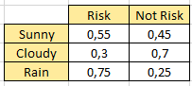
The Markov state diagram of weather changes in the Figure 6 graphically describes Transition probability matrix shown in Table 5.
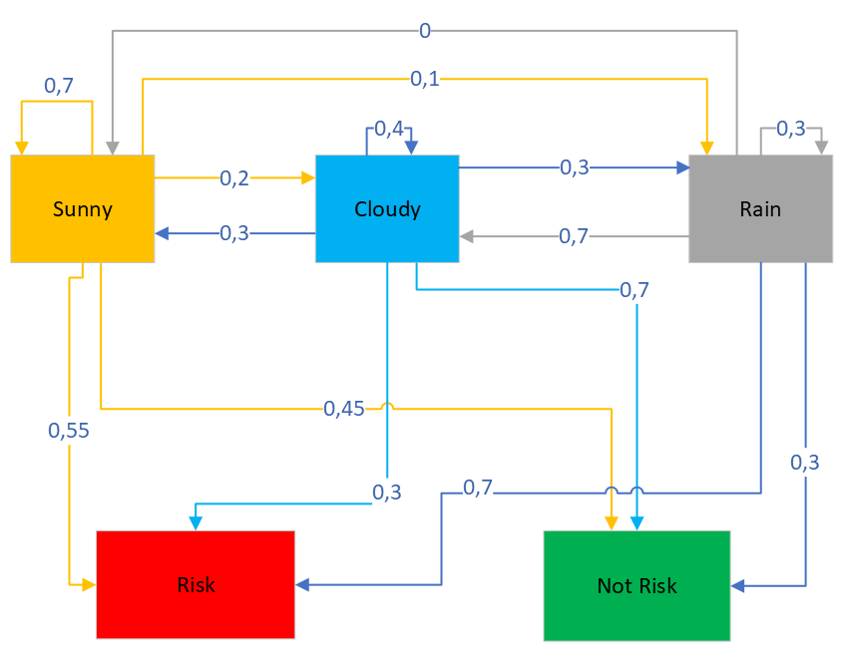
Figure 6: Markov state diagram of weather changes with Risk estimation included

All this is followed by the calculation of the probability of certain events/scenario. First example is shown in the Figure 7. This is calculated in next form:
Y represent risk or not risk state and X represent sunny, cloudy and rain states. So, the first example should be written in the following form:
P(Y= Risk, Not risk, Risk , X = Sunny Cloudy Rain)
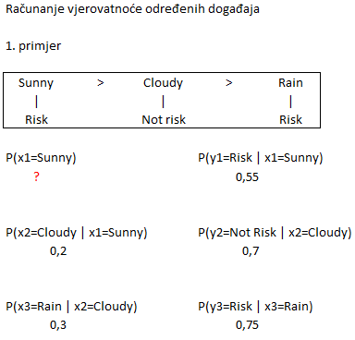
Figure 7: Calculation of probability for first scenario
The probability for all terms is available in the two previously mentioned matrices but what about first term? How to find the probability of the first state? Answer is stationary distribution for Markov chain.
One row vector is taken, let call it π, whose elements represent probabilities of the states. Basically, π denotes the probability distribution of the states. In example, in the beginning is sunny day, so the first element which correspondents to the Sunny becomes 1 and other two remain 0. Then that row should be multiplied to transition matrix to get second row. This process is shown in the Figure 8.
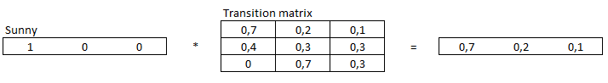
Figure 8: Multiplying row with transition matrix
Then the second row (result row) is used to multiply with the matrix as it is shown in the Figure 9.
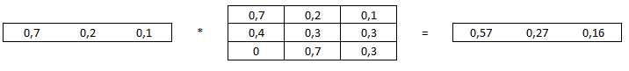
Figure 9: Multiplying second row with transition matrix
Process should be repeated until reached stationary state. If there exist a stationary state then after a certain point the output row vector should be exactly same as the input vector (Figure 12).
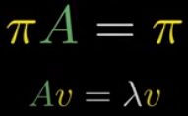
Figure 10: Eigenvector equation [15]
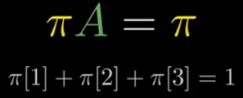
Figure 11: Eigenvector equation applied to this task [15]
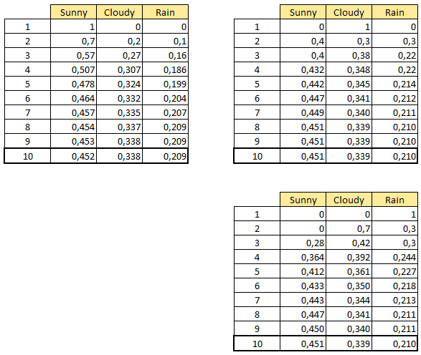
Figure 12: The process of reaching stationary state for Sunny, Cloudy and Rain states.

This process is done using integrated Excel function called MMULT ().
Now it is possible to determine probability for first, initial state.
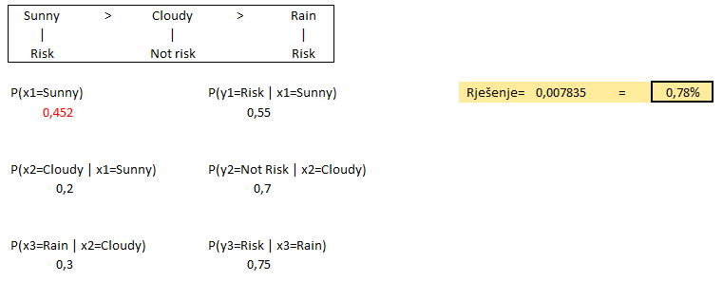
Figure 13: Calculation of probability for first scenario
The probability of certain events/scenarios is obtained by simply multiplying all probabilities (Figure 13).
After calculating different scenarios, it turned out that scenario from Figure 14 have highest probability.
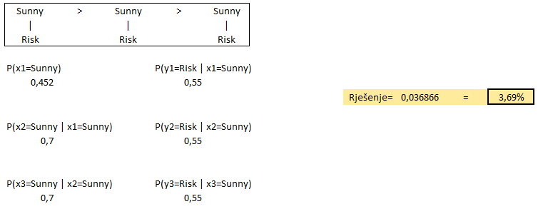
Figure 14: Scenario with highest probability

Discussion and Future work

Biometeorology is the study of weather's impact on living organisms including humans. One Pittsburgh Post-Gazette article concludes that weather itself, but specifically dramatic shifts in weather, can impact physical and even mental health. Jennifer Vanos, a biometeorologist, and assistant professor of atmospheric science at Texas Tech University said, "It's a huge swing physiologically," for record low of minus 9 degrees Fahrenheit [13].
Mentioned article also talks about mental problems caused by sudden changes in weather like depression or suicide rate. But in an unexpected seasonal twist, Mississippi State University meteorologist Grady Dixon said suicide rates drop during the winter. The peak season for suicides is June, he said [13].
"Usually, the thing people are most surprised to hear is that while people have depression in the cold, dark winter months, suicides around the globe, with no exception, most commonly occur during the late spring and early summer," he said. "It's the broken-promises effect. If you are clinically depressed and have seasonal affective disorder, you expect spring to be better. But if you are clinical ill, you probably won't get better in the spring when you expect to feel better. It is not the weather effect but the lack of a weather effect that causes suicide. [13]"
Other mentioned thing is that women are more cautious than men. Weather and climate psychologist Alan E. Stewart of the University of Georgia said men and women react differently to severe weather [13].
"Men take more weather-related risks than women, including driving across roadways that have water flowing, or being outside during thermal extremes, or not taking cover when thunder is heard and lightning is seen, or not sheltering when there's word from the National Weather Service of a storm or tornado," said Mr. Stewart [13].
Future work would include more on the research about weather’s impact on mental health and how both men and women can better prepare in advance for the upcoming weather changes and possibly include humidity and wind speed.

Conclusion

Sudden changes in weather, in air pressure and temperature can indeed have huge impact on people physical and mental health. The mechanism of changes in the occurrence of meteoropathy also depends on the atmospheric factor and the health condition of the person. E.g., exacerbation of rheumatic pain during a drop in atmospheric pressure occurs due to additional expansion of fluid and air within the joint envelopes causing pain. Extreme cold, but also moisture and heat irritate the mucous membrane of the respiratory and make breathing difficult in people suffering from inflammatory diseases of the respiratory system (bronchitis, asthma, chronic obstructive pulmonary disease, etc.). Also, extreme air temperatures can cause health problems and an increased number of deaths and therefore pose a public health problem.
From the project it can be concluded that the greatest health risk is caused by rainy weather. Health problems can also occur when the weather is sunny but only if temperatures are high.

References

[1] Livewell, Does Changing Weather Affect Our Bodies?, Accessed : 17.06.2022. Available: https://livewellhealthandphysiotherapy.com/2018/05/15/does-changing-weather-affect-our-bodies/
[2] Vanja Cvitković, Centarzdravlja, Accessed: 17.06.2022. Available: https://www.centarzdravlja.hr/zdrav-zivot/zdravlje-opcenito/kako-nagle-promjene-vremena-utjecu-na-organizam-i-kako-olaksati-tegobe/
[3] mr Marija Mašanović, dr. med. spec. javnog zdravstva, Accessed: 17.06.2022. Available: https://www.zzjzdnz.hr/zdravlje/okolis-i-zdravlje/meteoropatija
[4] Žagar-Petrović M. Meteoropatija – bolest vremena. Accessed: 17.06.2022. Available: https://www.zdravobudi.hr/clanak/81/meteoropatija-bolest-vremena
[5] Janiri L, Spinetti G, Mazza M, Di Nicola M. Meteoropathy: a new disease. Journal online "Ecology, Psichiatry and Mental Health, Cardiology & Dermatology " - Supplemento del Journal "Ecology, Psychiatry and Mental Health". Accessed: 17.06.2022. Available: http://www.psicocardio.org/index.php?option=com_content&view=article&id=28:meteoropathy-a-new-disease&catid=11:psichiatria&Itemid=111
[6] timeanddate, Past Weather in Mostar, Accessed: 9.06.2022. Available: https://www.timeanddate.com/weather/bosnia-herzegovina/mostar/historic
[7] Dan Ma, Introducing Markov Chains, Accessed: 22.06.2022. Available: https://probabilitytopics.wordpress.com/2017/08/12/introducing-markov-chains/
[8] Alberto Leon-Garcia, Probability, Statistics, and random processes for Electrical engineering Third edition
[9] William Lindsey, The Transition Matrix, Accessed: 22.06.2022. Available: https://www.youtube.com/watch?v=4zg5bNlHZRg
[10] Dan Ma, Chapman-Kolmogorov Equations, Accessed: 22.06.2022. Available: https://probabilitytopics.wordpress.com/2017/09/09/chapman-kolmogorov-equations/
[11] Rachelle Oblack, How to Read a Barometer Use Rising and Falling Air Pressure to Predict the Weather, Accessed: 22.06.2022. Available: https://www.thoughtco.com/how-to-read-a-barometer-3444043
[12] Hirohisa Okuma, Yumiko Okuma, and Yasuhisa Kitagawa, Examination of fluctuations in atmospheric pressure related to migraine, Published online 2015 Dec 18. doi: 10.1186/s40064-015-1592-4, Accessed: 22.06.2022. Available: https://www.ncbi.nlm.nih.gov/pmc/articles/PMC4684554/
[13] David Templeton, Major weather swings can be harmful to our physical, mental health, Accessed: 24.06.2022. Available: https://www.post-gazette.com/news/health/2014/01/10/Major-weather-swings-can-be-harmful-to-our-physical-mental-health-As-temps-swing-so-does-our-well-being/stories/201401100119
[14] Markovljevi lanci uvod, Available: https://www.youtube.com/watch?v=aw0csBsr4e8
[15] Markov Chains Clearly Explained! Part – 1, https://www.youtube.com/watch?v=i3AkTO9HLXo

